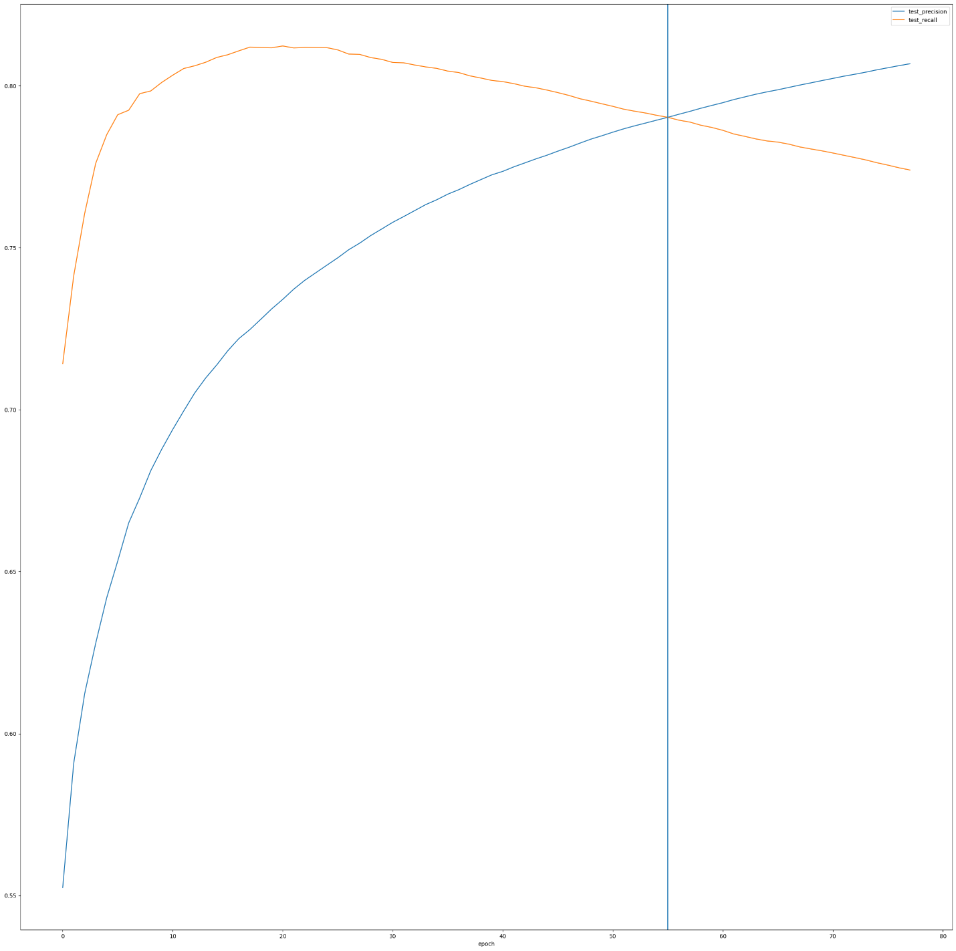

Location x=55

accuracy 0.936807

entropy 0.159588

entropy_large_set 0.250206

precision 0.899686

recall 0.983255

test_accuracy 0.790267

test_accuracy_nolang 0.754621

test_entropy 0.455127

test_entropy_nolang 0.516060

test_precision 0.790281

test_precision_nolang 0.740461

test_recall 0.790286

test_recall_nolang 0.784123

test_square_accuracy 0.905763

test_square_accuracy_nolang 0.873859

test_square_entropy 0.217335

test_square_entropy_nolang 0.284293

test_square_precision 0.868131

test_square_precision_nolang 0.835944

test_square_recall 0.956891

test_square_recall_nolang 0.930310

Name: 55, dtype: float64